Scrum

🧠 Definition
# Source: AI Source: Provided by: [Data Path: Persons Table -> ID Column: 1, Name_En Column: Motasem Essam] -> From: [ChatGPT] on [1/23/2026]
Scrum is one of the most popular frameworks within the Agile Model used to manage and develop complex software projects. It focuses on team collaboration, iterative progress, and continuous improvement through short development cycles called Sprints.
Scrum is an Agile framework that helps teams work together to deliver high-quality products incrementally, adapting quickly to changes and feedback.

🔁 How Scrum Works
# Source: AI Source: Provided by: [Data Path: Persons Table -> ID Column: 1, Name_En Column: Motasem Essam] -> From: [ChatGPT] on [1/23/2026]
- Work is divided into Sprints (usually 1–4 weeks)
- Each sprint produces a working product increment
- Teams hold regular meetings to track progress and improve
- Continuous feedback and adaptation are key

👥 Scrum Roles
# Source: AI Source: Provided by: [Data Path: Persons Table -> ID Column: 1, Name_En Column: Motasem Essam] -> From: [ChatGPT] on [1/23/2026]
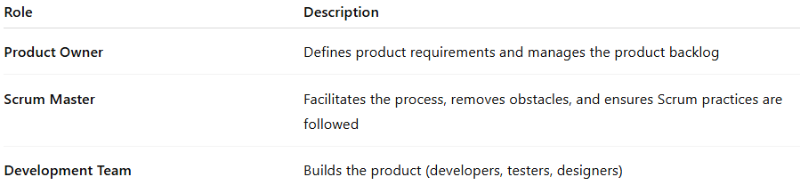
Role | Description
Product Owner | Defines product requirements and manages the product backlog
Scrum Master | Facilitates the process, removes obstacles, and ensures Scrum practices are followed
Development Team | Builds the product (developers, testers, designers)

📋 Scrum Artifacts
# Source: AI Source: Provided by: [Data Path: Persons Table -> ID Column: 1, Name_En Column: Motasem Essam] -> From: [ChatGPT] on [1/23/2026]
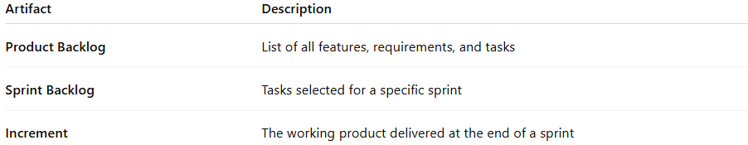
Artifact | Description
Product Backlog | List of all features, requirements, and tasks
Sprint Backlog | Tasks selected for a specific sprint
Increment | The working product delivered at the end of a sprint

📅 Scrum Events (Ceremonies)

📝 Sprint Planning
# Source: AI Source: Provided by: [Data Path: Persons Table -> ID Column: 1, Name_En Column: Motasem Essam] -> From: [ChatGPT] on [1/23/2026]
- Define what will be done in the sprint
- Select tasks from the product backlog

📢 Daily Scrum (Stand-up)
# Source: AI Source: Provided by: [Data Path: Persons Table -> ID Column: 1, Name_En Column: Motasem Essam] -> From: [ChatGPT] on [1/23/2026]
- Short daily meeting (≈15 minutes)
- Team discusses progress and blockers

🔍 Sprint Review
# Source: AI Source: Provided by: [Data Path: Persons Table -> ID Column: 1, Name_En Column: Motasem Essam] -> From: [ChatGPT] on [1/23/2026]
- Demonstrate completed work to stakeholders
- Gather feedback

🔄 Sprint Retrospective
# Source: AI Source: Provided by: [Data Path: Persons Table -> ID Column: 1, Name_En Column: Motasem Essam] -> From: [ChatGPT] on [1/23/2026]
- Reflect on what went well and what can improve
- Plan improvements for the next sprint

⚙️ Key Characteristics
# Source: AI Source: Provided by: [Data Path: Persons Table -> ID Column: 1, Name_En Column: Motasem Essam] -> From: [ChatGPT] on [1/23/2026]
- Iterative and incremental development
- Time-boxed sprints
- Self-organizing teams
- Continuous feedback and improvement
- Transparency and collaboration

✅ Advantages
# Source: AI Source: Provided by: [Data Path: Persons Table -> ID Column: 1, Name_En Column: Motasem Essam] -> From: [ChatGPT] on [1/23/2026]
- Faster delivery of working software
- High flexibility and adaptability
- Strong team collaboration
- Continuous improvement through feedback
- Better visibility of project progress

⚠️ Disadvantages
# Source: AI Source: Provided by: [Data Path: Persons Table -> ID Column: 1, Name_En Column: Motasem Essam] -> From: [ChatGPT] on [1/23/2026]
- Requires experienced and disciplined teams
- Scope creep may occur
- Less documentation compared to traditional models
- Daily meetings may feel repetitive

📝 When to Use Scrum
# Source: AI Source: Provided by: [Data Path: Persons Table -> ID Column: 1, Name_En Column: Motasem Essam] -> From: [ChatGPT] on [1/23/2026]
- Projects with changing or unclear requirements
- Teams that benefit from frequent feedback
- Fast-paced development environments
- Products requiring continuous improvement

📌 Summary
# Source: AI Source: Provided by: [Data Path: Persons Table -> ID Column: 1, Name_En Column: Motasem Essam] -> From: [ChatGPT] on [1/23/2026]
Scrum is a widely used Agile framework that organizes work into short sprints, with defined roles, artifacts, and events. It emphasizes team collaboration, flexibility, and continuous delivery, making it ideal for dynamic and complex software projects.

